PREDICTIVE MODDELING OF MAZIE PRICES IN MALAWI: INTERGRATING MACHINE LEARNING MODELS WITH RAINFALL, FERTILIZER PRICES AND HISTORICAL MAIZE PRICE DATA.

BY

PROMISE KELECHI MTHUNZI

A RESEARCH PROJECT PROPOSAL SUBMITTED TO THE FACULY OF DEVELOPMENTAL STUDIES IN PARTIAL FULFILMENT FOR THE AWARD OF BARCHELOR OF SCIENCE DEGREE IN AGRICULTURAL ECONOMICS

LILONGWE UNIVERSITY OF AGRICULTURE AND NATURAL RESOURCES
(LUANAR)

P.O. BOX 219
LILONGWE

MARCH, 2025.
Table of Contents
1. INTRODUCTION 3
2. LITERATURE REVIEW 6
3. METHODOLOGY 9
4. RESEARCH OUTPUT AND IMPACT 12
5. REFERENCES 12

INTRODUCTION
  - Background
Data is the foundation of all megatrends that are currently happening, in finance and banking, data is used to predict stocks and currency changes, in Healthcare, data is used in epidemiology and modeling disease infection rate, in E-commerce we have customer behavior analysis and personalized advertisements.
In technology we have witnessed the dawn of more advanced machine learning models and artificial intelligence systems, these computer programs uses vast amount of data to train, learn and perfect their problem solving techniques. So though data can be used to draw inferences, another important aspect is its ability to help in predicting future events, this capability raise a critical question for agriculture-reliant nations like Malawi on how data can be employed to forecast agriculture related phenomena’s.

Agriculture production is considered a dynamic system, especially when it is not mechanized. just like weather, predicting rainfall patterns and other climate phenomena’s that affect agriculture can become cumbersome, the same applies to crop prices, without future contracts and contract farming, the prices that crops fetch on the market are volatile, they change with levels of supply, which is affected by rainfall and prices of inputs such as fertilizer.
Maize is one of important crops in Malawi, in recent years, there has been an increase in participation in maize production across the country, at the same time, we have witnessed frequent changes in prices of maize and maize products, as a stable food, the government often intervenes by buying buffer stocks, setting ceiling and floor prices, and subsidizing inputs, however, many of these interventions have had a limited impact on the overall changes of maize prices, recently, due to an increase in both domestic and foreign demand, maize prices have become so volatile.
Understand the power of data in addressing this issue is essential, by leveraging predictive models, we can help to forecast maize prices which can help in making more data-driven decisions by both farmers and stakeholders.

  - Problem Statement
In economics we dwell much to answer the most economizing problem of output maximization which extends to what to produce, how to produce and how much, with scarce resources. To address this problem we focus on resource optimization and allocation efficiency, in farm business management, production and cost analysis requires output revenue which is calculated by dividing total production cost over output price. Knowing the price of a product will fetch, is important to help in knowing what quantity of production will breakeven and at what price and quantity will the farm start realizing profits. But one major challenge that famers face is not having enough information of what will be the opening, closing and the changes of maize prices after production. This uncertainty of prices makes it hard for producers to determine production levels and storage period. Thus lately the prices of maize have been so volatile making it hard for both famers and business firms to make more informed decision on when to sell their produce.

  - Study Objectives

    - Main Objective
The main objective of this study is to create a robust model that can accurately forecast maize prices with rainfall, fertilizer prices and historical maize prices as the predictor variables.

    - Specific Objectives
- Develop and validate a forecasting model that utilizes the selected predictor variables to forecast maize prices.
- Comparing the performance between ARIMA models and Machine Learning models in forecasting.
- Evaluating the accuracy and performance of the models in predicting maize prices.

  - Research Hypothesis
    - Null Hypothesis: There is no significance relationship between the predictor variables (Past maize prices, fertilizer prices and rainfall) and current maize prices in Malawi.

  - Justification/Significance of the study
Planning in maize production is not an easy task for most famers in Malawi as it difficult to tell the prices that the crops will be sold in the next season. Knowing the prices, or at least knowing the possible future scenario and variation of maize prices in time will help the famers in allocation efficiency, the high cost of maize production nowadays due to increase in factor cost means famers need to plan properly on how the available inputs can be utilized, most famers also cannot afford to purchase farm inputs such as maize seed, fertilizers and chemicals, most rely in Inputs loans organization such as one acre fund, talking a loan also required planning, at what quantity will the output breakeven and at what selling price will they start realizing profits. This requires prior knowledge of prices.

The model can also help financers, stakeholders and the government in making informed decisions when it comes to policy formulating and enhancing existing ones, the government can anticipate period of high maize prices and plan how to shied vulnerable groups against food shortages.
The model can also help in designing strategies that can help to stabilize maize prices. This can be, by keeping reserves which can be supplied in the market during high prices and assisting the overall macro-economic situation in Malawi.

LITERATURE REVIEW
  - Key Concepts, Theories and Studies
Maize Growing and Market Dynamics in Malawi
Maize is arguably one of the most important economic crops in Malawi. Not only as a stable food but recently it is competing to be an important cash crop, in late 90s, it used to be grown locally for consumption purposes but recently due to increasing demand for both domestic and export purposes, thus the current demand of maize has drove both smallholder farmers and estate owners to invest much in the production of maize. With time, we have witnesses a lot of people going into the maize production, driving the prices up for production resources such as land, labor, inputs which include hybrid maize seed, fertilizers and chemicals.
The nations maize output comes from both rain-fed and irrigated sources, but the majority, which significantly impact the economic outlook, relies on rain-fed agriculture. This makes rainfall and precipitation among the most important variable in maize production. Drought and natural disasters such as cyclone have played a bigger role in determining the output of maize in the country,
In 2023, it is recorded that over 179,000 hectares of maize crop was affected by cyclone Freddy, in 2024(George.Phiri, 2024), the nation experienced a dry spell which caused 22% decline in the nation’s output of maize(Charles Mpaka, 2023)
Due to free market economy, the prices of maize is mostly influenced by market forces of demand and supply, there has been previous interventions from the government to moderate prices such as buying maize during harvest from smallholder farmers and selling them later at lower prices but the system does not function as intended. This and other factors make the price of maize so volatile making it hard for famers to make informed decisions.

Machine Learning Algorithms and Models in Econometrics
Machine learning algorithms are advanced computer models that are built to learn from data, modern AI (Artifical intelligence) systems uses vast amount of data to learn how to address given problems. When that data belongs to economic discipline, it turns out to be economic modeling. Econometrics uses a combination of statistical models to specify relationships that exist between many economics phenomena. A simple linear regression is frequently used in economic modeling to come up with an intuitive relationship between various economic entities. So there is no gap between these two, what really matters is the data used and the purpose of the model.

Forecasting and Predicting.
The use of statistical tools and mathematics has been the modern approach to build economic models that helps in predicting future outcomes, by analyzing the relationships between causes and events of past phenomena’s, economists can predict by probability the likelihood of an event to happen in the future following a certain action.

Time series Analysis
Let’s dive deeper in the intuition of data we will work with, a time series is a data frame indexed in time. Each individual observation is a data point that is normally indexed in time, a few examples of time series data include, rainfall records, Sales Data, GDP, Financial information like Stock prices and Currency exchange rates.
The main characteristic is that each time interval has got its own observation and we use time series techniques in analysis and prediction of future values using the past information is what called forecasting.

Tools Used in Time series Analysis and Forecasting
There different tools and algorithms used to analyze and model time series data, but they are mainly categorized in two.
- Linear / Statistical tools. E.g.AR models, ARIMA, SARIMA, ETS (Exponential Smoothing),VAR (Vector Autoregression), Exponential Smoothing models and Holt’s Winter models.
- Non-linear /Machine learning Algorithms. E.g. LSTM, RNN, RANDOM FOREST, SVM, DECISION TREES and K-Nearest Neighbors.
The nature of the data used also predetermining which model to employ, whether data is univariate or multivariate. Understanding the nature and context of the data is prerequisite in deciding which model to use which requires a comprehensive EDA.
A univariate time series has its own series as the only dependent and a single independent variable and we often employ AR Linear Statistical tools in modeling.
Multivariate data on the other hand has more than one independent variable and predicting future values required advanced algorithms such as Neural Networks and Classification models.

  - Key Debates and Controversies.
In forecasting future events, significant debates revolve around the accuracy and reliability of predictive models. The choice of algorithms used in modeling often influences the outcomes, as different models can yield varying results. Furthermore, the future in inherent stochastic, with each phenomenon shaped by random factors and external shocks that can alter the trajectory and probabilities of events.

  - Methodological Review
For long time, linear statistical methods, such as ARIMA, have been widely employed in modeling; however, these methods often fall short when addressing nonparametric and nonlinear relationships. Recent studies, including those by Lapedes and Forbes, suggest that models like Artificial Neural Networks (ANN) and Nonlinear Vector Autoregression (NLVAR) can be more effective in forecasting nonlinear time series
He also used the same research to compare ARIMA AND Artificial Neural Network (ANN) models; he concluded that ANN models can be excellent in improving predicting ability for time series models
Furthermore, evaluation of model performance is also another important part of model development; most popular evaluation metrics for ARIMA models include RMSE (root mean squared error) and MAPE (mean absolute percentage error). The linear models emphasize on minimizing these errors. R-Squared is also used in model evaluation. Better models have values closer to 1.
In machine learning, we often conduct cross validation when we want to analyze model performance, and that is we use the same data to test the model by splitting it. So a percentage of it is used in training and the other percentage is used in testing.

  - Gaps in Existing Knowledge
The research is not complementary in nature, its development of an idea, time series models are used in different sectors of our nation including in agriculture, such as forecasting weather patterns. But not much has been done in creating a platform on which famers and stakeholders can rely on when it comes to projecting future changes of crop prices. The research will also employ different techniques thereby improving the accurateness and reducing standard errors.

METHODOLOGY
  - Conceptual Framework

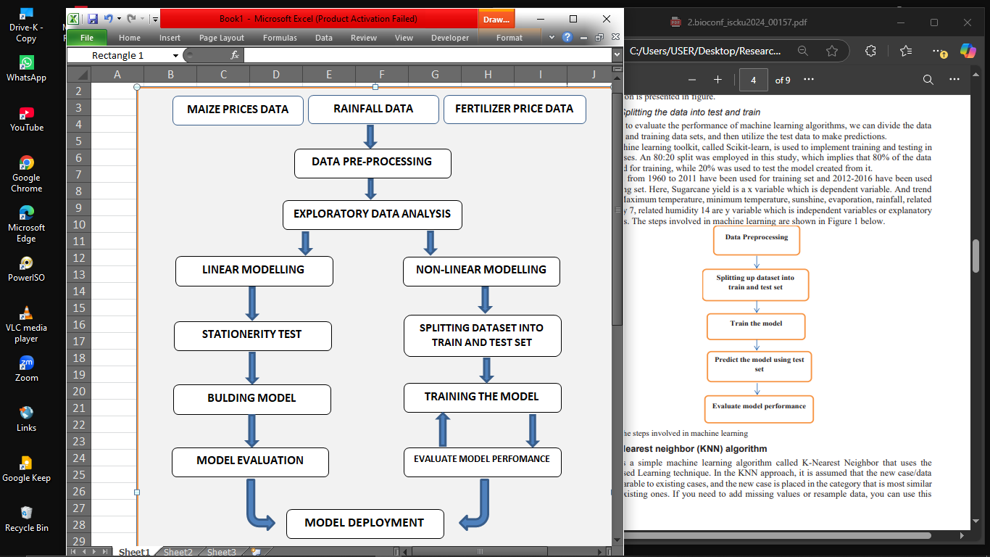

  - Theoretical Framework

The research will require the researcher to take a two way approach, the first approach; simple linear model of ARIMA OR SALIMA will be employed depending on the data, which will be helpful to come up with model parameters and illustrate the interaction between the variables, data merging, restructuring and reshaping will happen prior to model development, the first approach will also require the series to be stationery, thus the researcher will conduct all required data processing and cleaning. Since ARIMA often assumes that present values are only affected with its own past values and noise, the first approach model in ARIMA will only use historical maize prices and predict future maize prices, meaning at all things constant, other variables which include rainfall data and fertilizer price data will not be relevant. Thus the first model will only evaluate model performance in predicting future maize prices based on its own lagged values. The researcher will use R-Programming, or STATA, whatever he will deem more convenient at that time, thus in both model development, running ADF test, making data stationery which include differencing or applying log transform. And then the effectiveness of the model will be determined by different evaluation metrics such as MAPE and MAE, MSA or RMSA.
The second approach, the researcher will employ machine learning models in trying to create a more robust model that interacts with other variables, in this case rainfall and fertilizer prices, The researcher requires to have a deep understanding and knowledge about machine learning models and coding in Python. The ending result is assumed to be a time series graph showcasing how prices of maize will change in time and at each level with its own level of significance. The idea primarily is to create a computer program that takes in data and learn from it and present the forecast. Given the nature of the model, the researcher will identify which machine learning model to use and which python modules to apply to train and test the model performance.

  - Empirical Model
Research objective: develop a model that accurately predict maize prices
Data: Gather all required data which include maize prices, rainfall and fertilize prices
Model choice: ARIMA model for univariate modeling and ANN models for multivariate modeling
Model building: build a model by splitting the data into training and testing
Model validating: evaluate the performance of each model by using different evaluation metrics

  - Study Area
This model will be built in such a way that it can take in any data variables of historical maize prices, rainfall and fertilizer prices and be able to forecast maize prices, the researcher will obtain the required data in Zomba, so the model will initially only be applicable for Zomba district but might also work if we feed it data from other areas.

  - Sampling Design and Strategy.
Considering the nature of this research, sample size will be determined intuitionally by the researcher taking into consideration a sample size that will be able to provide all time series functions and be able to capture all required trends and seasonality that can affect the outcome of the model.
Often most of the seasonal patterns in rainfall and price data are per year basis. But often most require more recent data and 3 to 5 seasonal patterns, thus the data will be from 2022 until 2025 to at least capture 4 seasons patterns.

  - Data Source, Variable Definition and Measurement.
This is a quantitative research, the three variables, Maize prices, amount of rainfall and fertilizer prices are both continuous numerical variables.
Data will be corrected in various sources, Government agriculture offices can provide data on rainfall and maize prices, the data can also be collected in Agriculture research stations, on the other hand, fertilizer price data will be collected in retail shops such as Famers world, Export trading group and AGORA.

  - Data Analysis.
Since data will be corrected from different sources, organizing and entry will be done in excel, data cleaning and validation, which include checking for outliers will also be conducted in excel.
In multivariate time series we need each variable value to be consistent and pegged on a same date, week, quota or month. The researcher will employ different techniques such as linear interpolation, forward and backward fill.
The researcher will use both Excel and Python in conducting exploratory data analysis, other data reshaping and manipulation tasks will be executed during model development in R or Python, so it will be a process of using tools which can simplify the work at hand.

  - Limitation of the study
There are a lot of independent factors that affect prices of maize in a developing nation like Malawi, maize being the face of Agriculture has a lot of government interventions in production, distribution and pricing. A good example, the most notable one, will be in 2004, Malawi recorded the highest production of maize because of the fertilizer subsidy program. We can say when supply of maize increases, the prices often decreases as one of the basic supply and demand laws in play. Meaning a more advanced model should try to capture the change in prices as a result of national production because prices are also generally affected. But in trying to keep the model simple, that element has been left out, exporting and importing can also affect supply of maize on the domestic market.

RESEARCH OUTPUT AND IMPACT

Planning is a pivotal part in agriculture production, as people are slowly moving out of subsistence farming and taking farming as a business, we need to employ different techniques which can help famers make more informed decisions, having a projection of the price their produce will fetch after harvest doesn’t only help the famers, but also investors, loan organizations, farming industry cooperation’s and manufacturing industries in price mechanism and storage routine.
The model will be dynamic in a sense that, the output will depend on the data used, meaning it can take in data from every district including data of other crops, meaning it will be static in this research but can be employed in other places.

- REFERENCES

- Ramadhan, A. J., Priya, S. R. K., Pavithra, V., Mishra, P., Dash, A., Abotaleb, M., Alkattan, H., & Albadran, Z. (2024). Machine Learning Techniques for Sugarcane Yield Prediction Using Weather Variables. BIO Web of Conferences, 97. https://doi.org/10.1051/bioconf/20249700157
- Kolavalli, S., Mensah-Bonsu, A., & Zaman, S. (2015). Agricultural Value Chain Development in Practice: Private Sector–Led Smallholder Development.
- Ghutake, I., Verma, R., Chaudhari, R., & Amarsinh, V. (2021). An intelligent Crop Price Prediction using suitable Machine Learning Algorithm. ITM Web of Conferences, 40. https://doi.org/10.1051/itmconf/20214003040
- Géron, A. (n.d.). Hands-On Machine Learning with Scikit-Learn and TensorFlow.
- Mailund, T. (2017). Beginning Data Science in R: Data Analysis, Visualization, and Modelling for the Data Scientist. In Beginning Data Science in R: Data Analysis, Visualization, and Modelling for the Data Scientist. Apress Media LLC. https://doi.org/10.1007/978-1-4842-2671-1
- VanderPlas, J. (n.d.). Python Data Science Handbook. www.allitebooks.com
- Wickham, H., & Grolemund, G. (n.d.). R for Data Science. www.allitebooks.com

